What does Bi tools do?

We can visualise the data

Analysis

Data is the new oil.

Decision making

**BI tools Architecture?**

Framework

BI Architecture refers to framework that refers to support the collection,integration,analysis and presentation of business data

* Data Sources-Where data originates(eg.spreadsheets,database,Web)
* ETL process-Extract,transform,Load process to prepare data for analysis.
* Data warehouse-where to store the data
* Tools-software for analysing data-PowerBI
* Presentation layer-Dashboard and reports

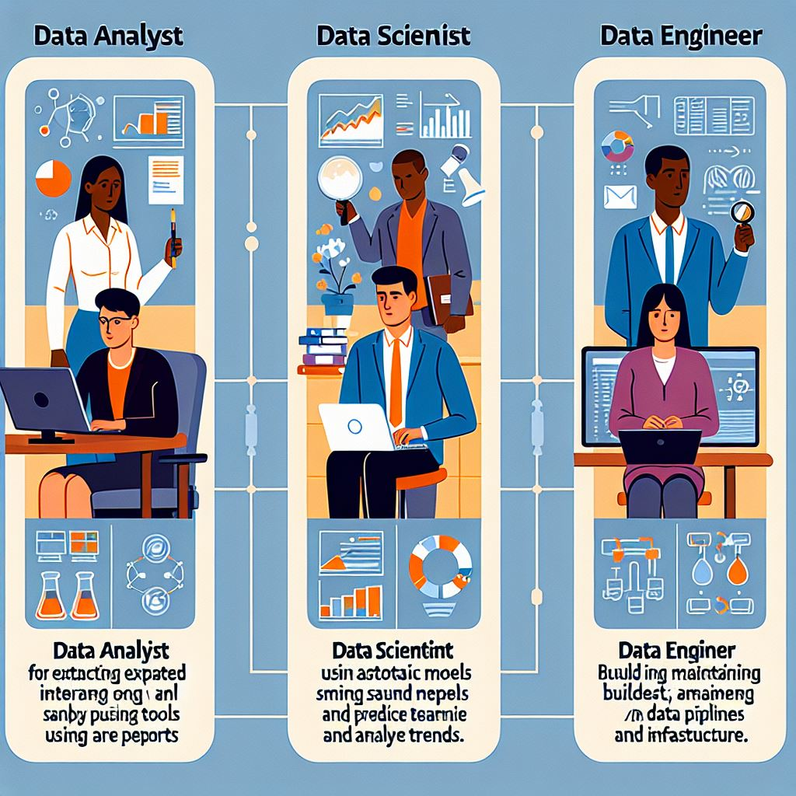

# Data analyst

Responsibilities:

* Data cleaning
* Visualisation
* Statistical analysis
* Present the findings

Skills-SQL,Excel,PowerBI,Tableau,Python,R,statistical analysis

# Data engineer:

Responsibilities:

* Data pipeline-system for data collection and processing
* Database management-efficiency and security
* Data integration-combine data from various sources

Skills-SQL,Python,R,Hadoop,spark

# Data scientist

Responsibilities:

* Predictive modelling
* Data mining
* Test hypothesis
* Explain finding to stakeholders

Skills-python,r ,sql,ml models,tensorflow

| **Role** | **Key Skills** |
| --- | --- |
| **Data Analyst** | - Data Cleaning and Preparation |
|  | - Data Visualization (e.g., Tableau, Power BI) |
|  | - Statistical Analysis |
|  | - Excel and SQL |
|  | - Reporting and Dashboard Creation |
|  | - Basic Programming (e.g., Python, R) |
|  | - Business Acumen |
|  | - Communication Skills |
| **Data Scientist** | - Advanced Statistical Analysis |
|  | - Machine Learning and AI |
|  | - Data Mining |
|  | - Programming (e.g., Python, R) |
|  | - Big Data Technologies (e.g., Hadoop, Spark) |
|  | - Data Visualization (e.g., Matplotlib, Seaborn) |
|  | - Deep Learning Frameworks (e.g., TensorFlow, PyTorch) |
|  | - Domain Expertise |
| **Data Engineer** | - Data Pipeline Development |
|  | - ETL Processes (Extract, Transform, Load) |
|  | - Database Management (e.g., SQL, NoSQL) |
|  | - Big Data Technologies (e.g., Hadoop, Spark) |
|  | - Cloud Platforms (e.g., AWS, Azure, GCP) |
|  | - Programming (e.g., Python, Java, Scala) |
|  | - Data Warehousing (e.g., Redshift, Snowflake) |
|  | - Performance Optimization |

What is Powerbi?

Powerbi Is a business analytics tool developed by Microsoft that allows users to visualise data and share insights across organisation or embed them in app or website.

How To Install Powerbi??

Go to Appstore🡪>powerbi🡪install/GET

Open the Powerbi

Components of Powerbi??

1.Powerbi desktop-Creating reports and visualisations

2.Powerbi service-Online Sharing and collaboration.

3.Powerbi Mobile-Accessing Powerbi on mobile

4.Powerbi Gateway-conneting with data source.